*5.3 Design*

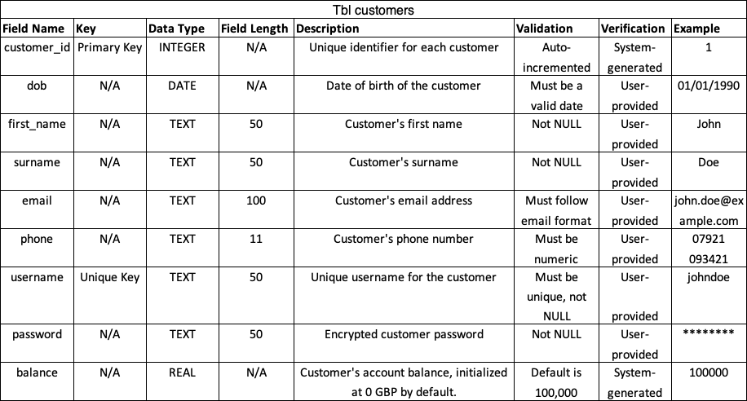Data Dictionary



